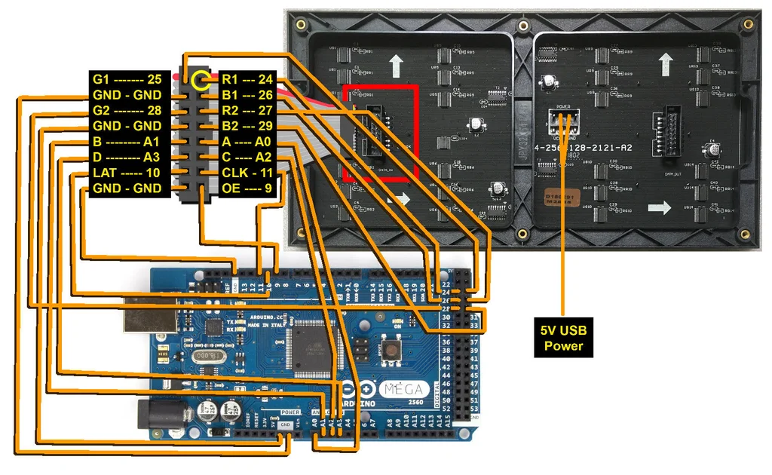

#### Short-Term: Barrel Jack

Grab a 5V wall adapter. Both been tested to work with the panels as well. At least in the short term.

* [5V/2A Wall Adapter](https://www.sparkfun.com/products/12889)
* [USB 5V/1A Wall Adapter](https://www.sparkfun.com/products/11456) (with [USB Barrel Jack Adapter](https://www.sparkfun.com/products/8639))

Use the power supply in conjunction with a [female barrel jack adapter](https://www.sparkfun.com/products/10288) and [screwdriver](https://www.sparkfun.com/products/9146) to get a quick and dirty connection between the spade and barrel jack.

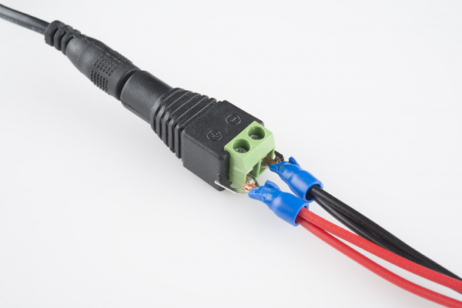

The final connection should look like the image below.

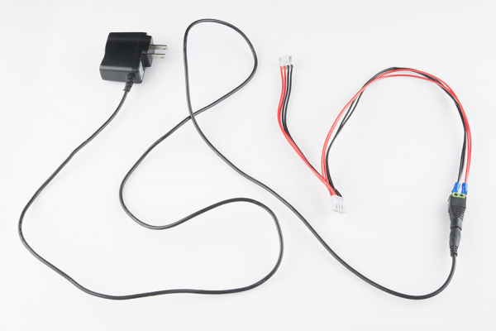

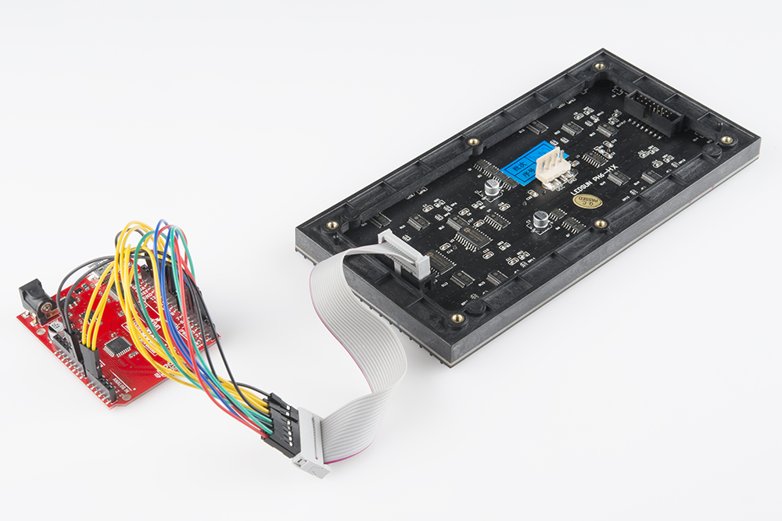

ADA matrix with the Arduino Mega wired